WEATHER PREDICTION USING AZURE AI
ABSTRACT
This project focuses on developing a weather prediction model using Microsoft Azure AI services. The model utilizes Azure Machine Learning Studio, Azure Cognitive Services, and Time Series Insights to analyze historical weather data and forecast future conditions. This solution has applications in disaster preparedness, agriculture, and climate adaptation, offering real-time, data-driven insights.

INTRODUCTION
With the increasing unpredictability of weather patterns due to climate change, the need for accurate weather forecasting models has grown significantly. This project leverages Azure AI tools to develop a machine learning model capable of predicting weather conditions based on historical datasets. The model was designed using no-code and low-code AI solutions available in Azure, making it scalable and efficient.

PROBLEM STATEMENT
Accurate weather prediction is essential for various sectors, including agriculture, disaster management, and public safety. Traditional forecasting methods often struggle with real-time adaptability. This project aims to bridge that gap using Azure AI-powered predictions, enhancing forecasting accuracy and reliability.

SOCIAL RELEVANCE
1. Disaster Preparedness
Early predictions of extreme weather events can help in timely evacuation and damage prevention.
2. Agricultural Benefits
Farmers can use weather forecasts to optimize planting schedules, irrigation plans, and harvesting periods, improving yield and reducing losses.
3. Climate Change Adaptation
Monitoring long-term weather patterns helps researchers and policymakers develop strategies for climate adaptation and mitigation.
4. Public Health & Safety
Weather predictions assist in anticipating disease outbreaks related to climate conditions, such as malaria and dengue.
5. Environmental Protection
Forecasting weather anomalies can aid in forest fire prevention and water conservation efforts.

METHODOLOGY
1. Project Goals
- Develop a weather prediction model using Azure AI tools.
- Train and validate the model on real-world weather datasets.
- Optimize model performance for accurate predictions.
2. Tools & Technologies Used
- ☁ Azure Machine Learning Studio – Model development & deployment.
- 📊 Azure Time Series Insights – Analyzing historical weather trends.
- 📈 Azure Cognitive Services – Enhancing feature extraction.
3. Model Development Phases
Phase 1: Data Preparation
- Collected historical weather data from Kaggle datasets.
- Uploaded data to Azure ML Studio for processing.
Phase 2: Model Training & Validation
- Configured AutoML for selecting the best predictive model.
- Fine-tuned hyperparameters for better accuracy.
Phase 3: Deployment & Monitoring
- Successfully deployed the model for real-time forecasting.
- Monitored model performance using Azure Time Series Insights.

EXPERIMENTAL RESULTS
The model was tested using multiple historical datasets and evaluated on accuracy, precision, and recall. Initial challenges included data preprocessing issues and computational constraints, which were resolved through feature engineering and iterative training.
service system.
Figure 5.1 create workspace
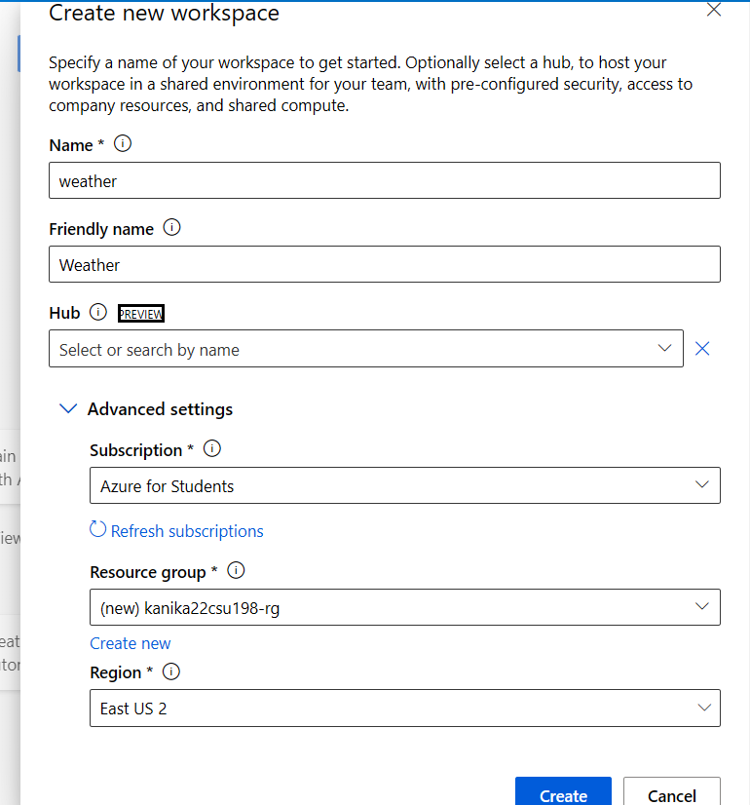
Figure 5.2: launch studio
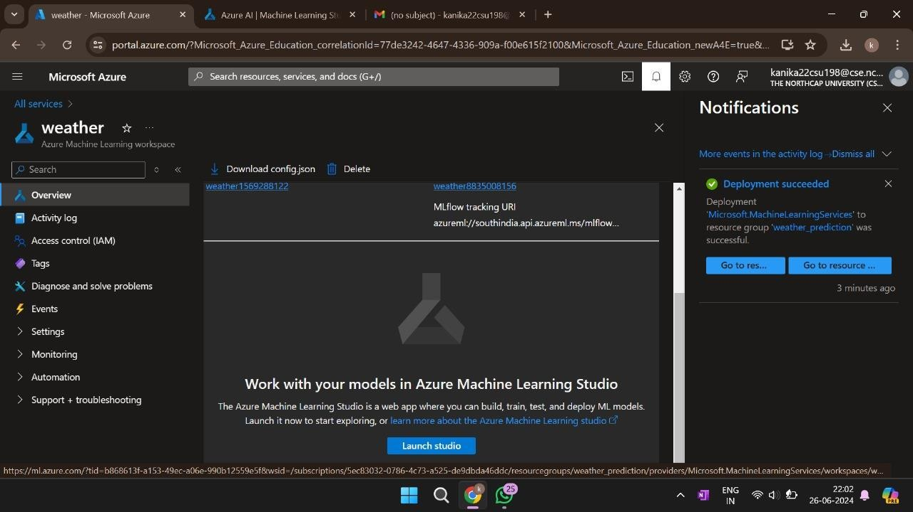
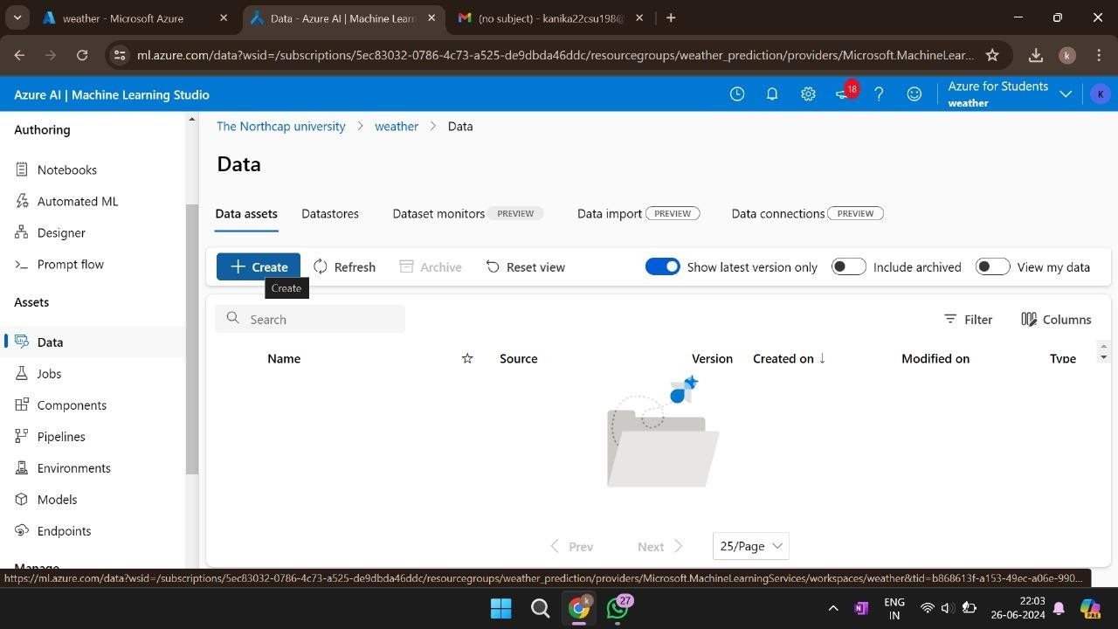
Figure 5.3: create dataset
- 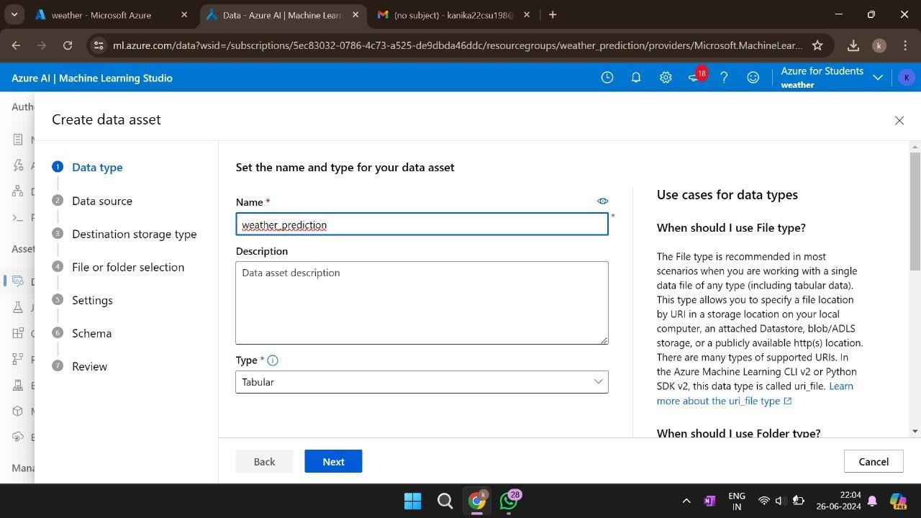
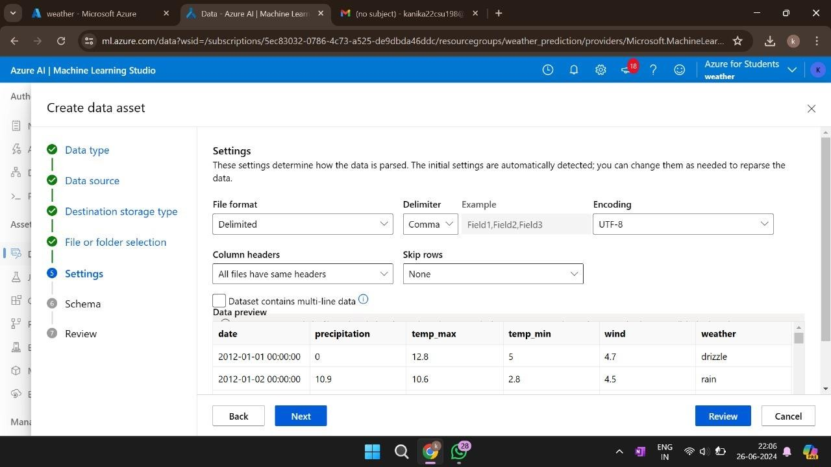
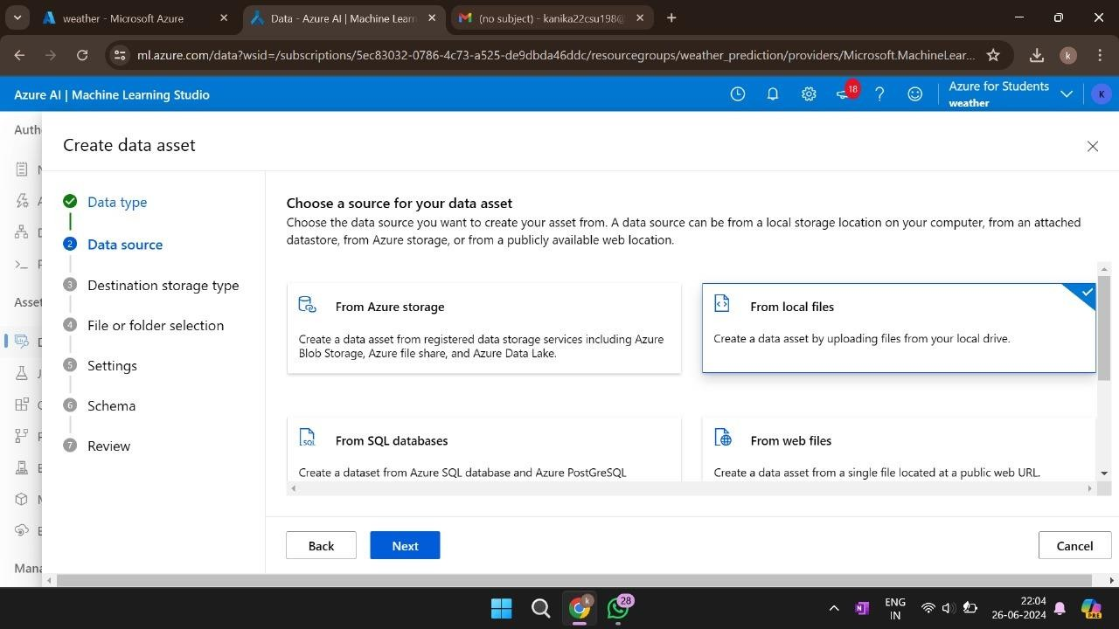
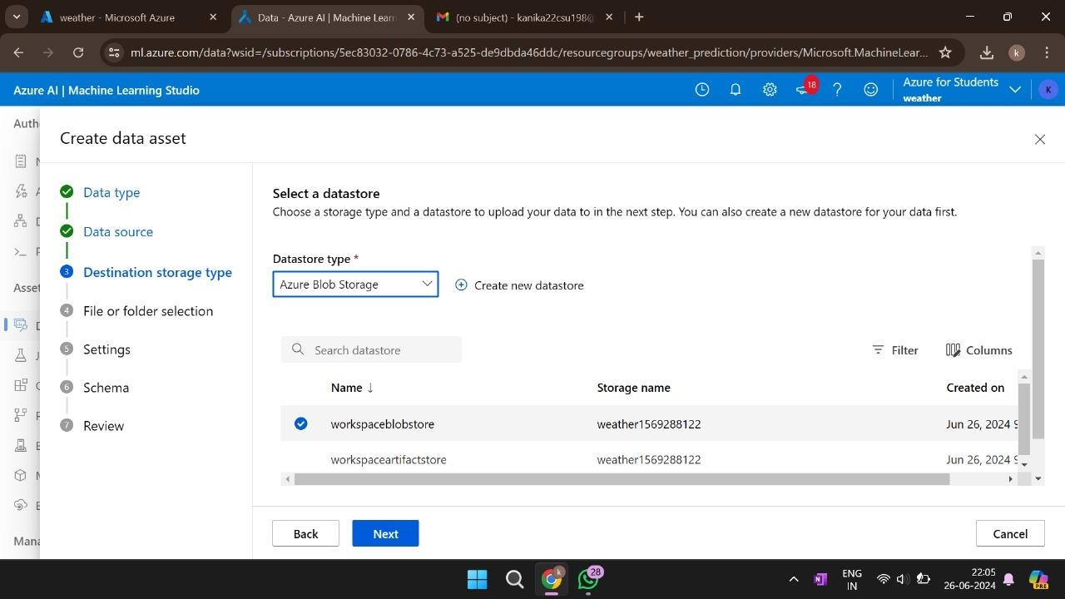
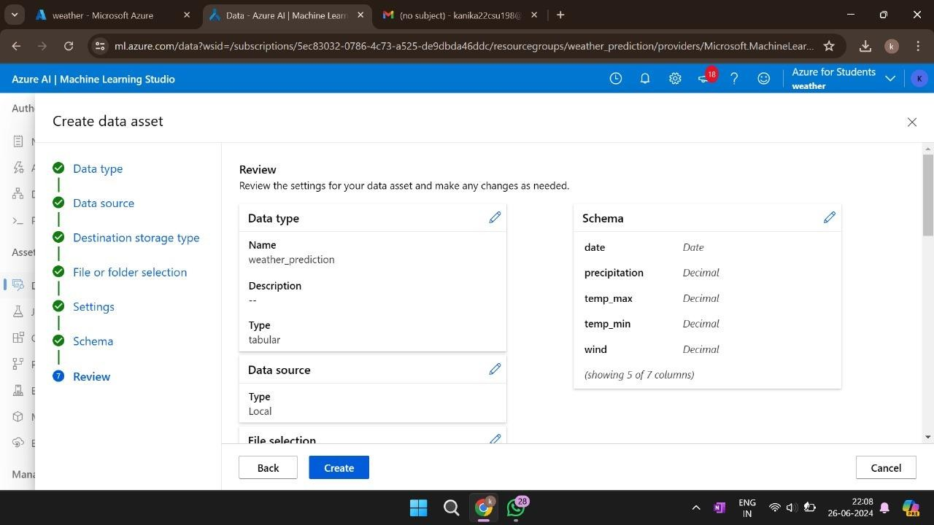
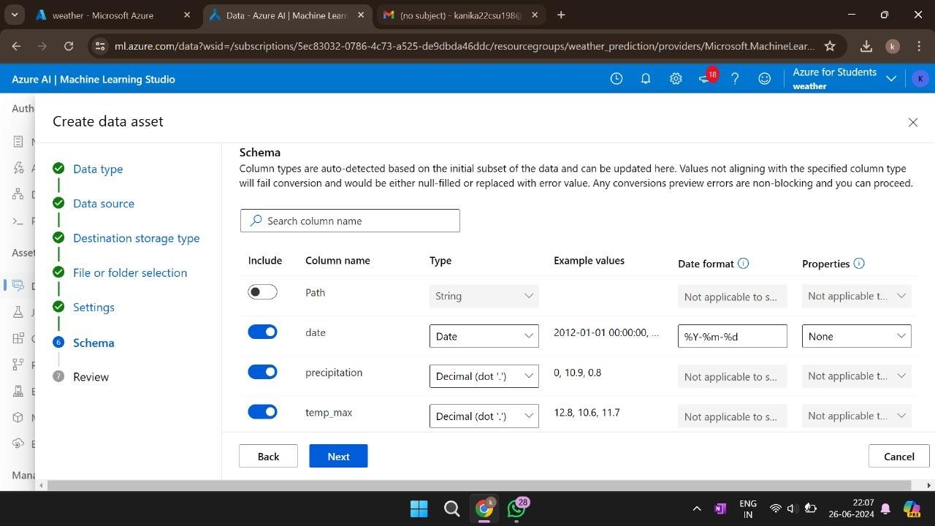
Figure 5.4: create compute instance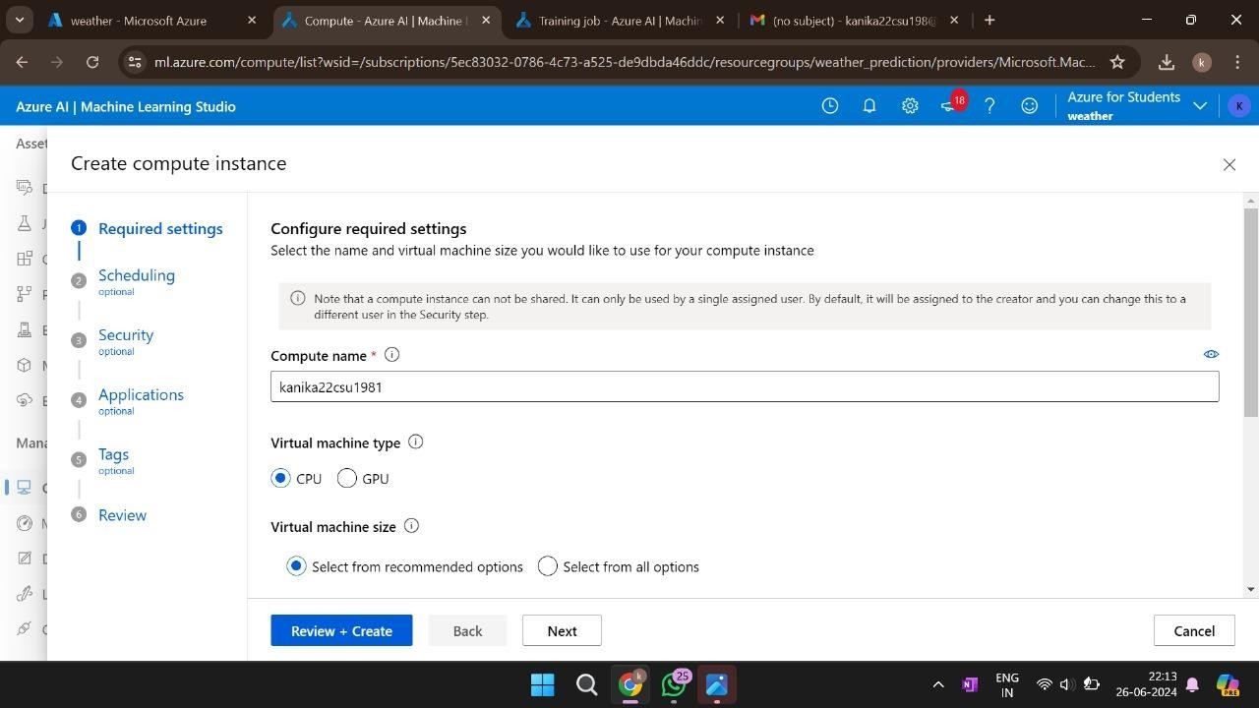

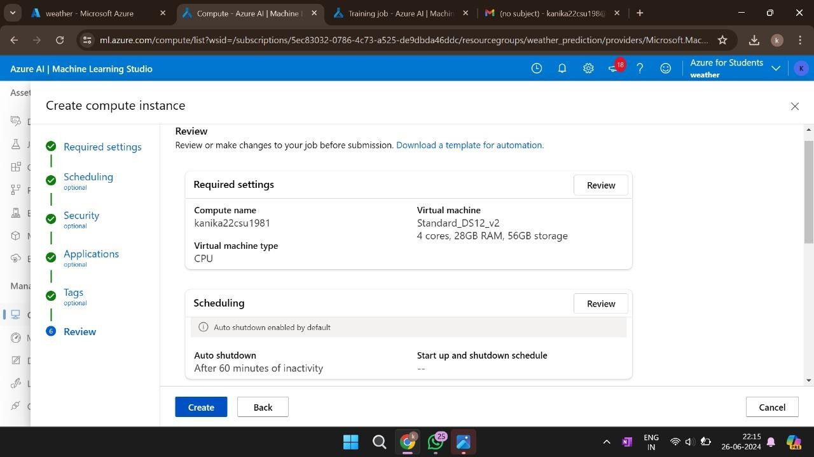
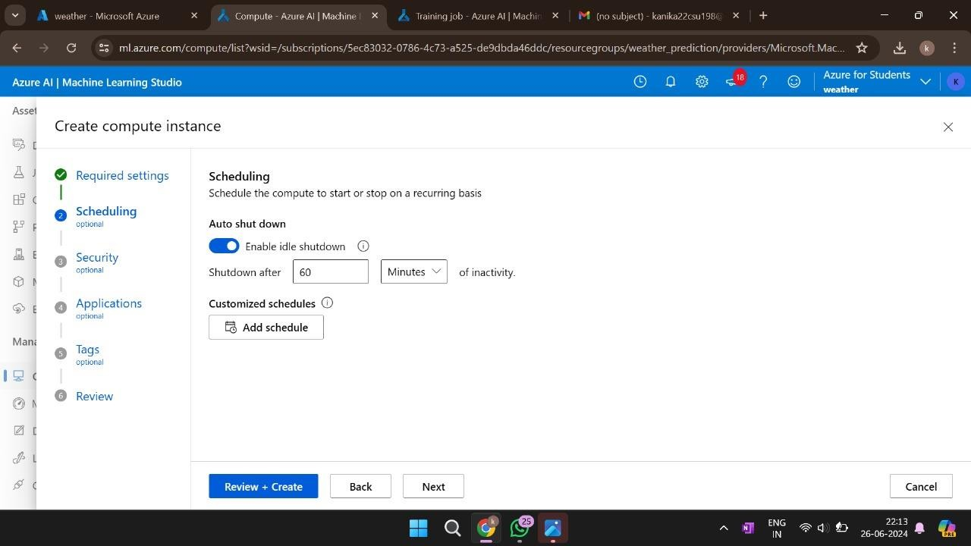
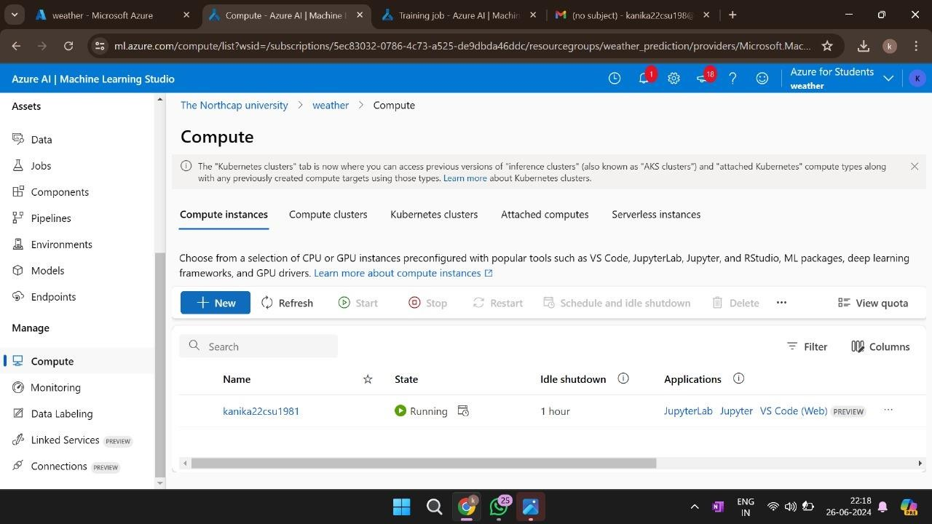
figure: 5.5 submit automated ml job

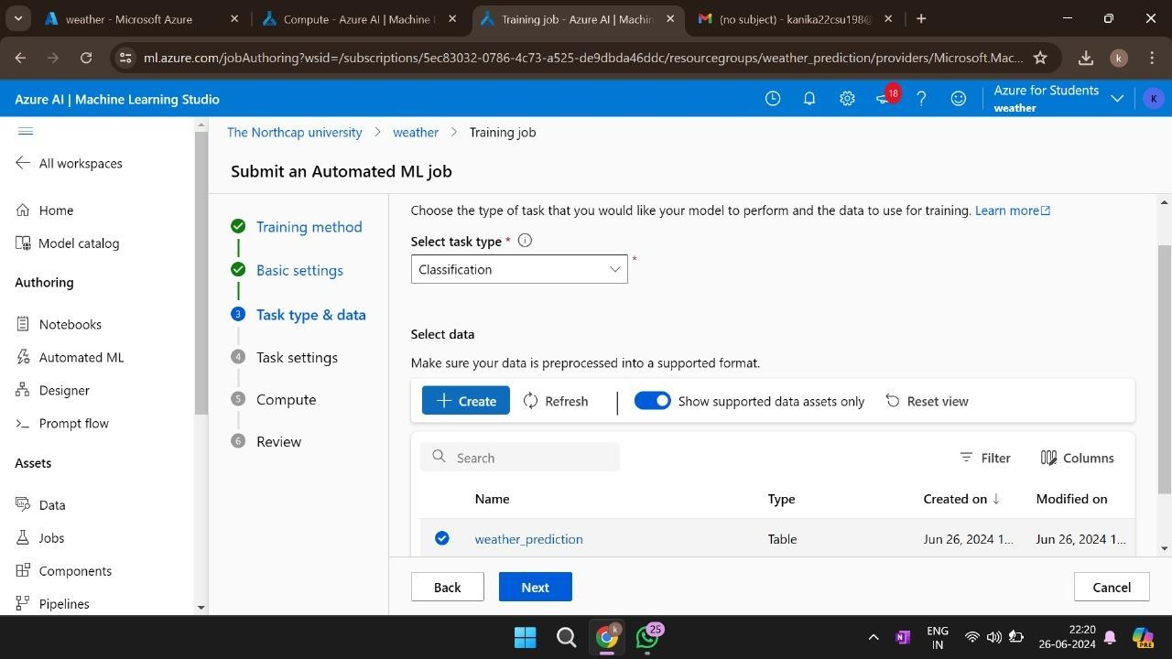

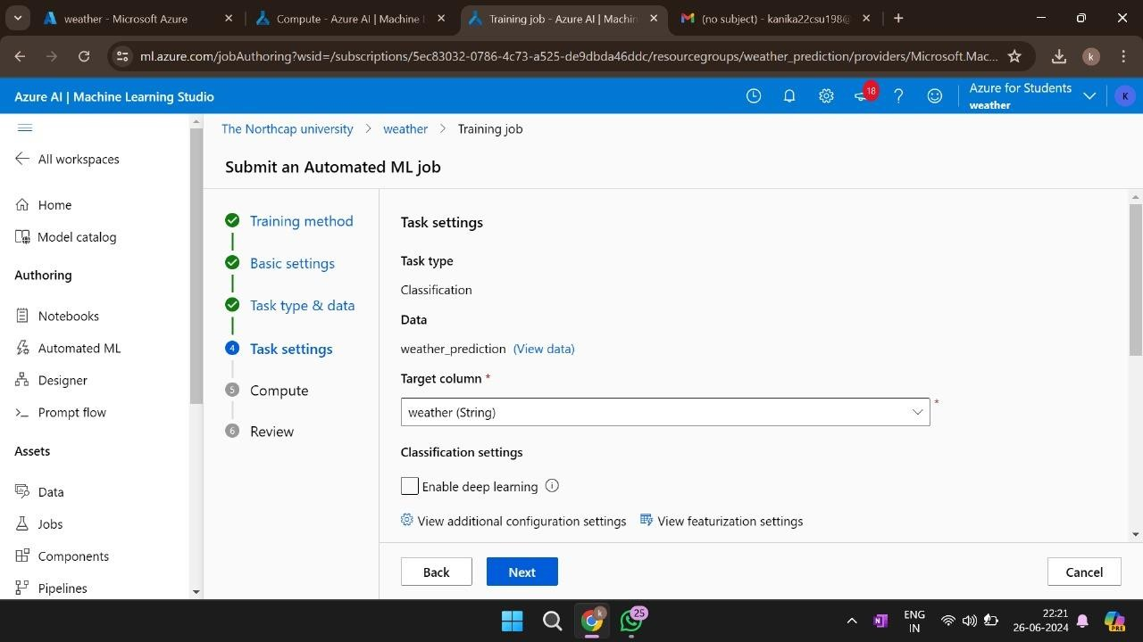

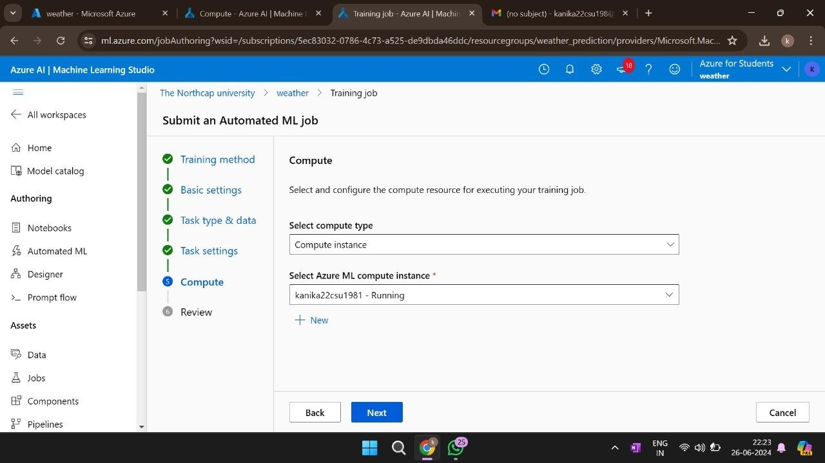

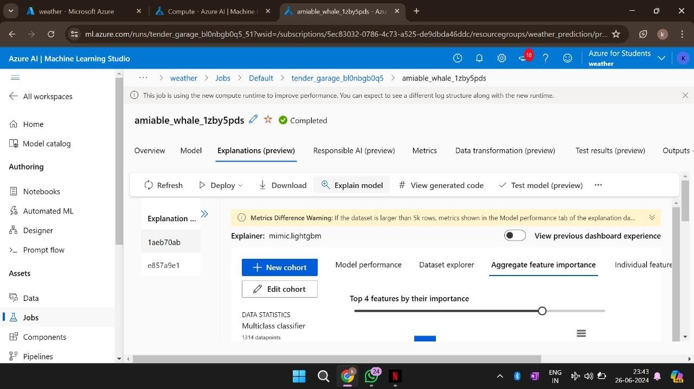
figure: 5.6 explain job
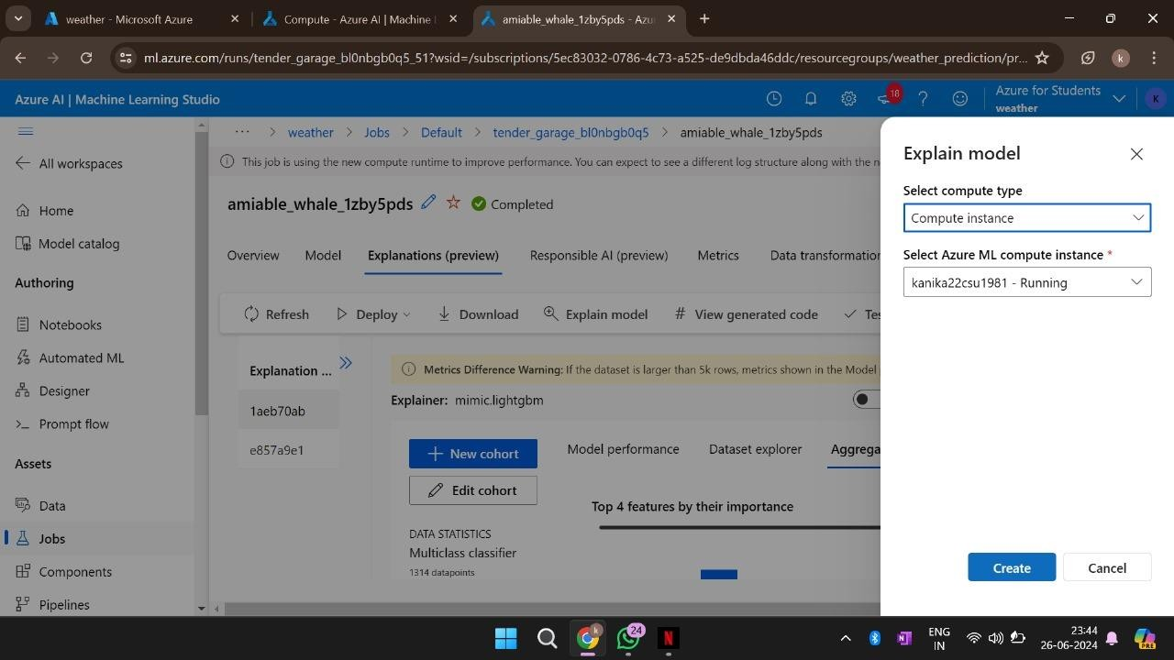
Figure 5.7: test model
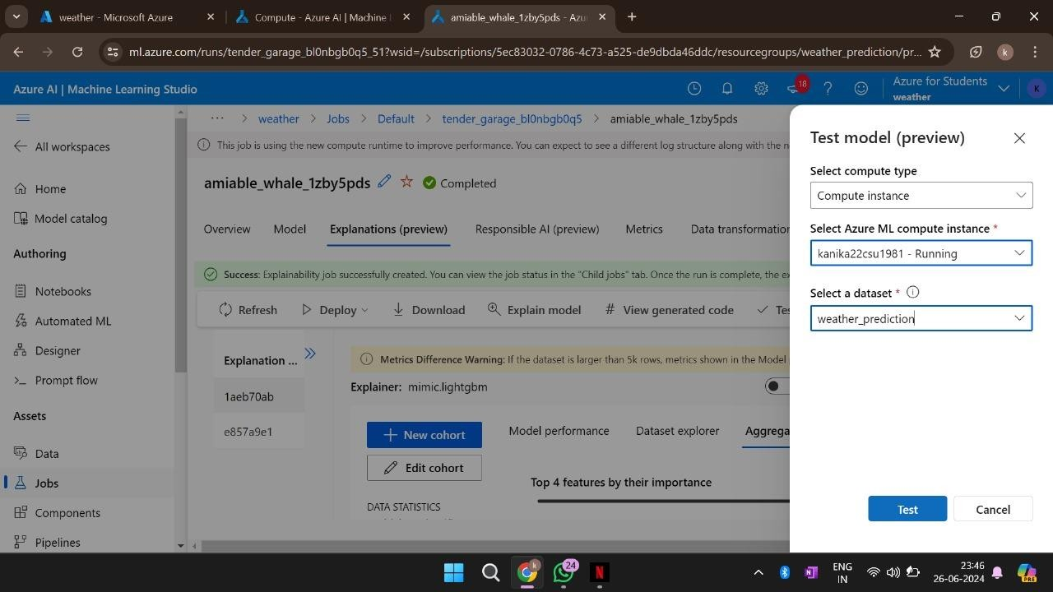
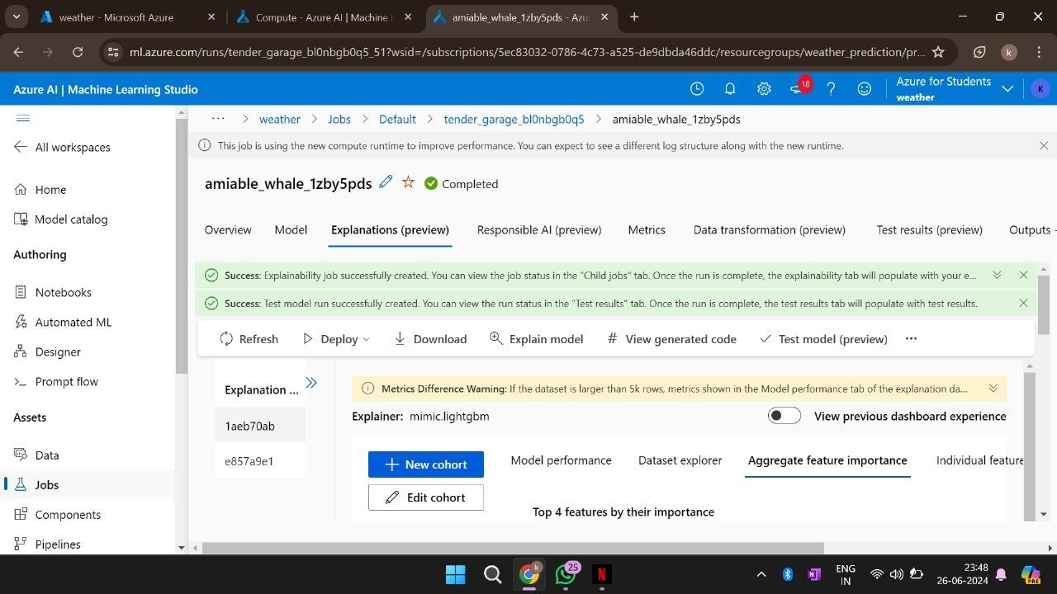
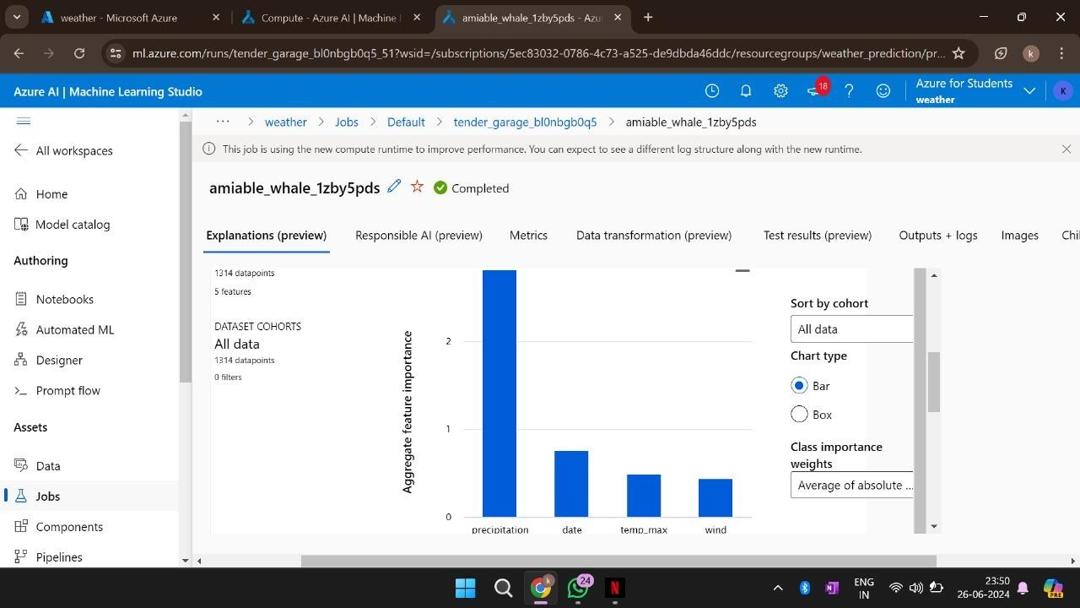
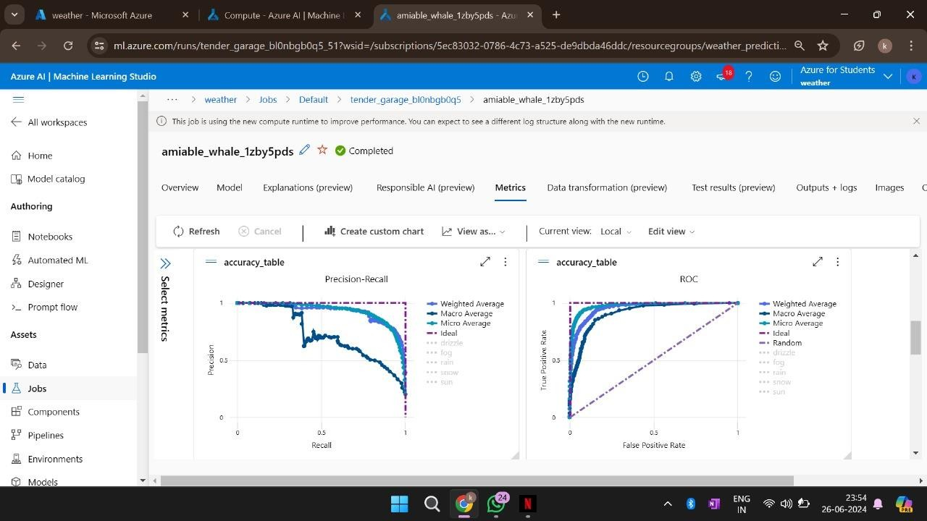
previewing
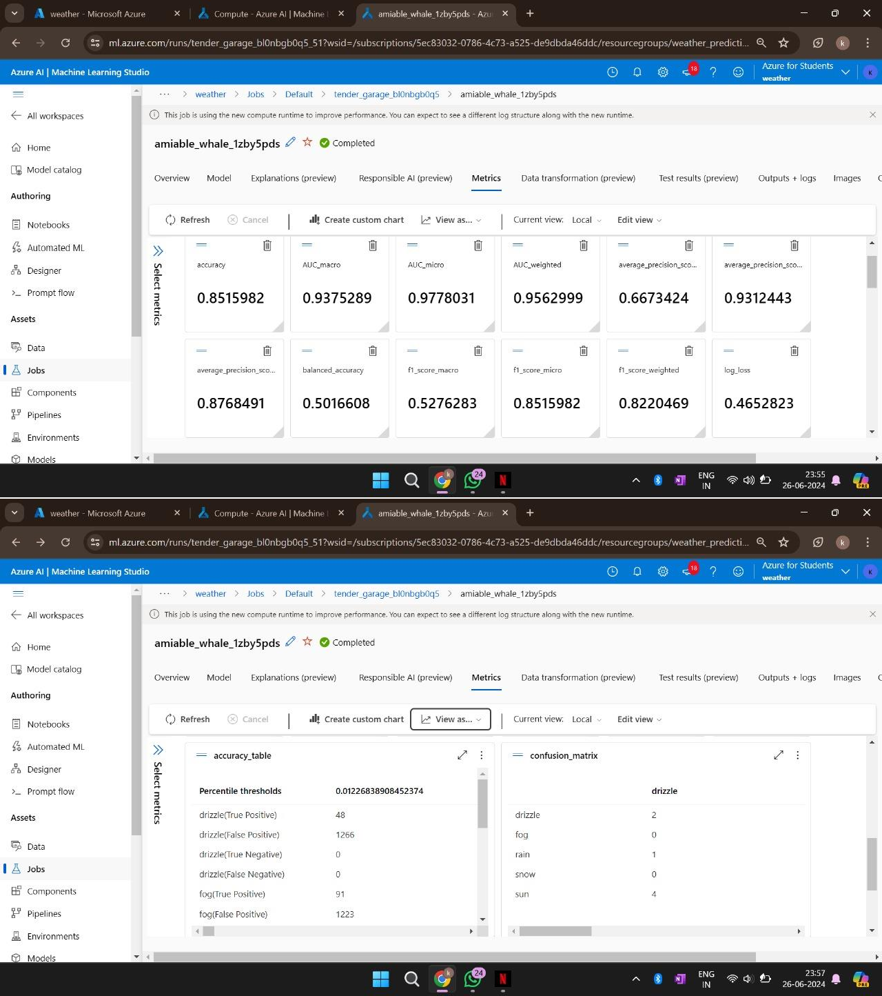
Figure 5.8: deploy automated ml job
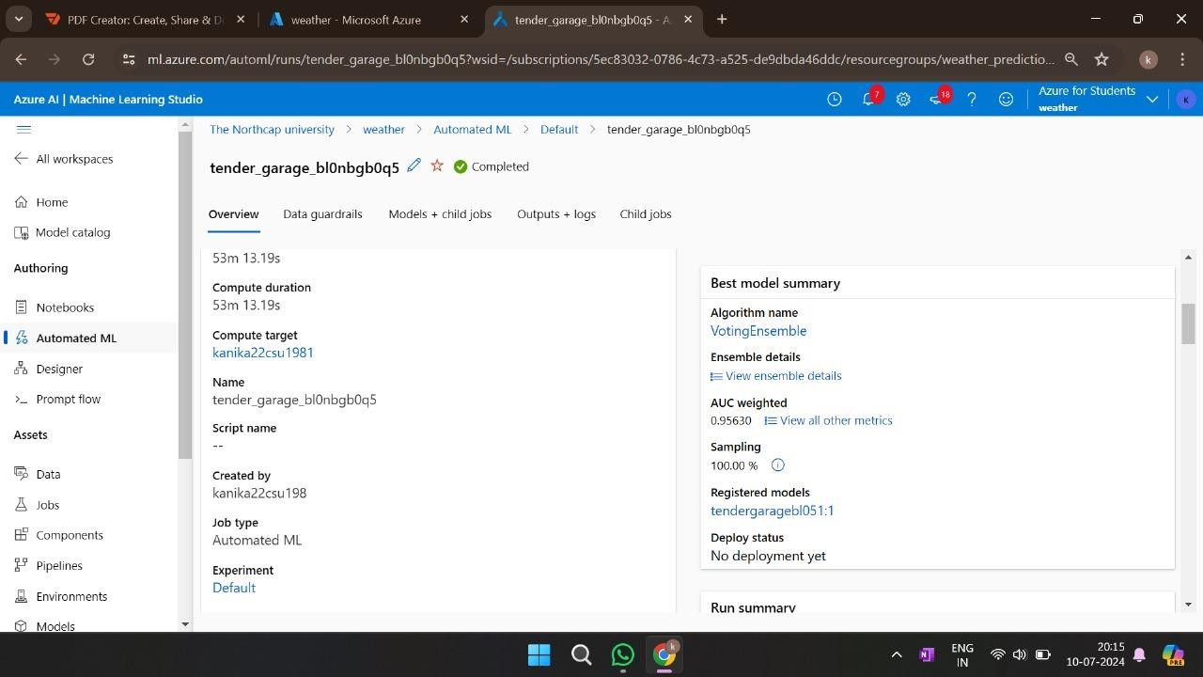
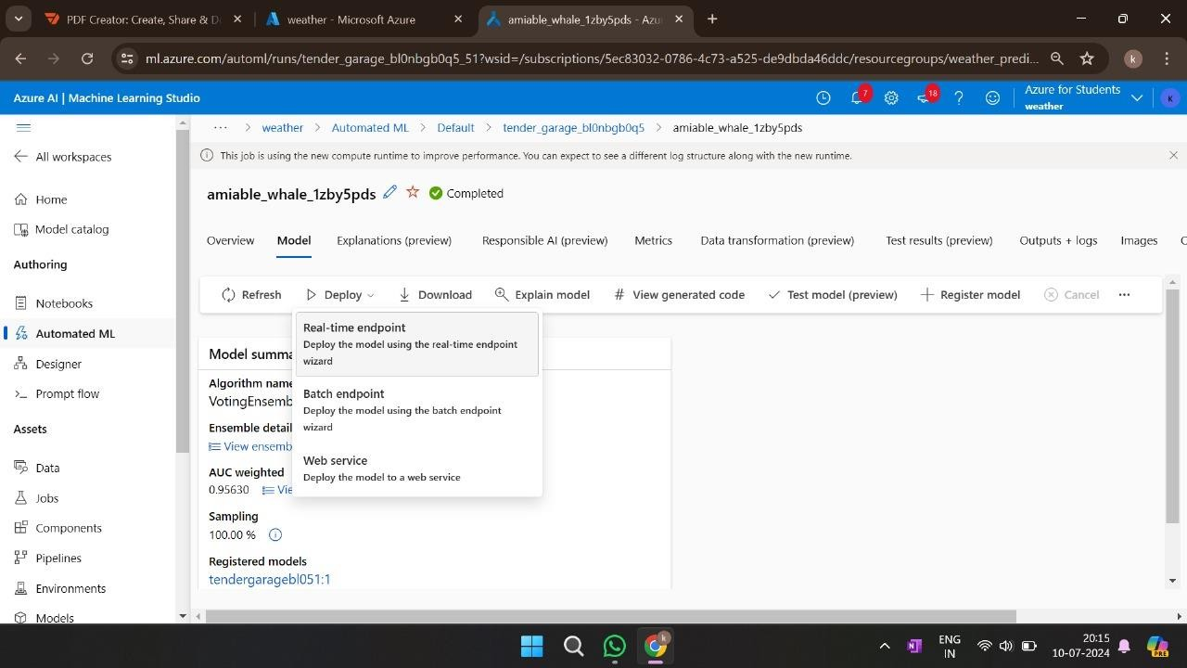

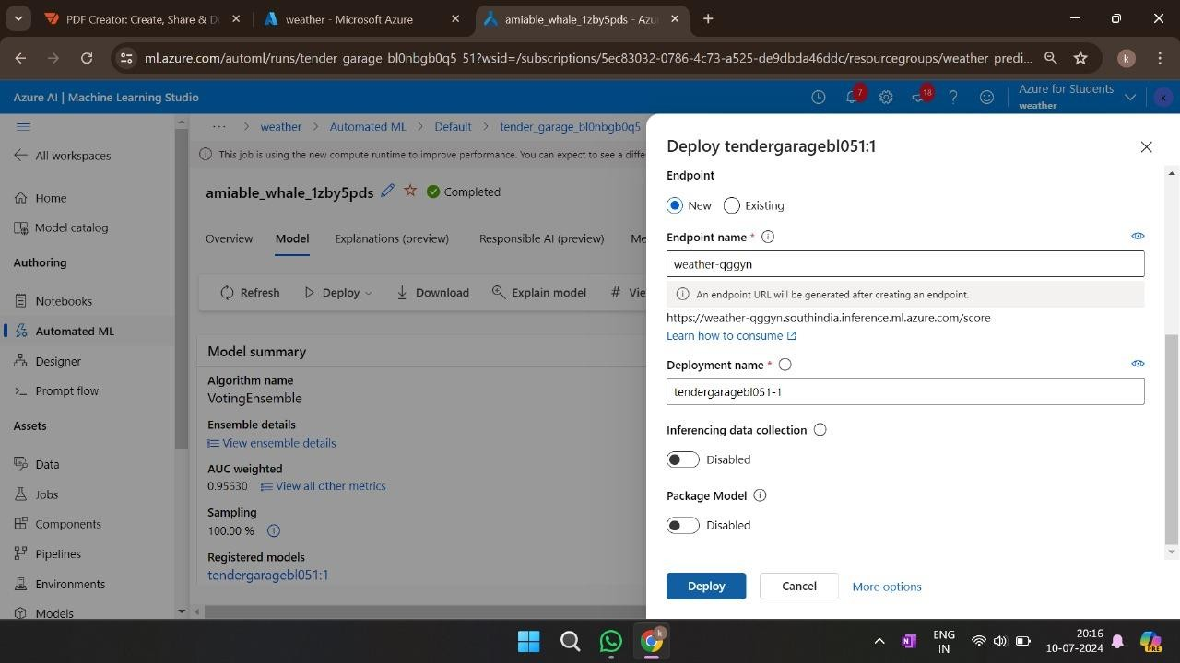
Figure 5.9: consume endpoints
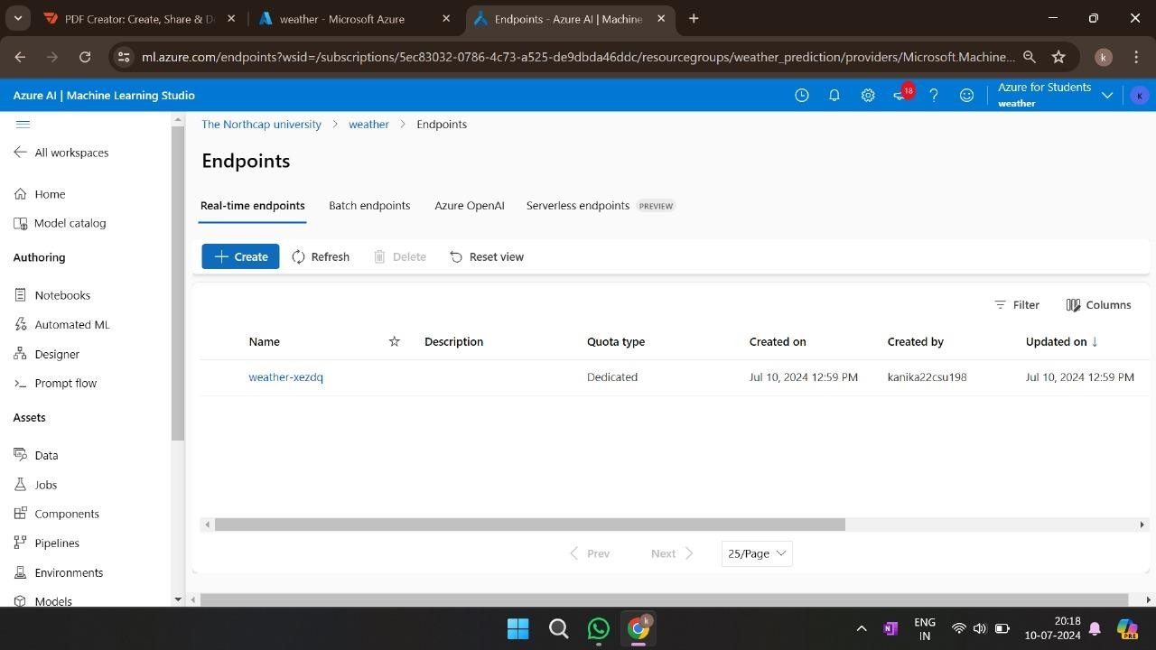
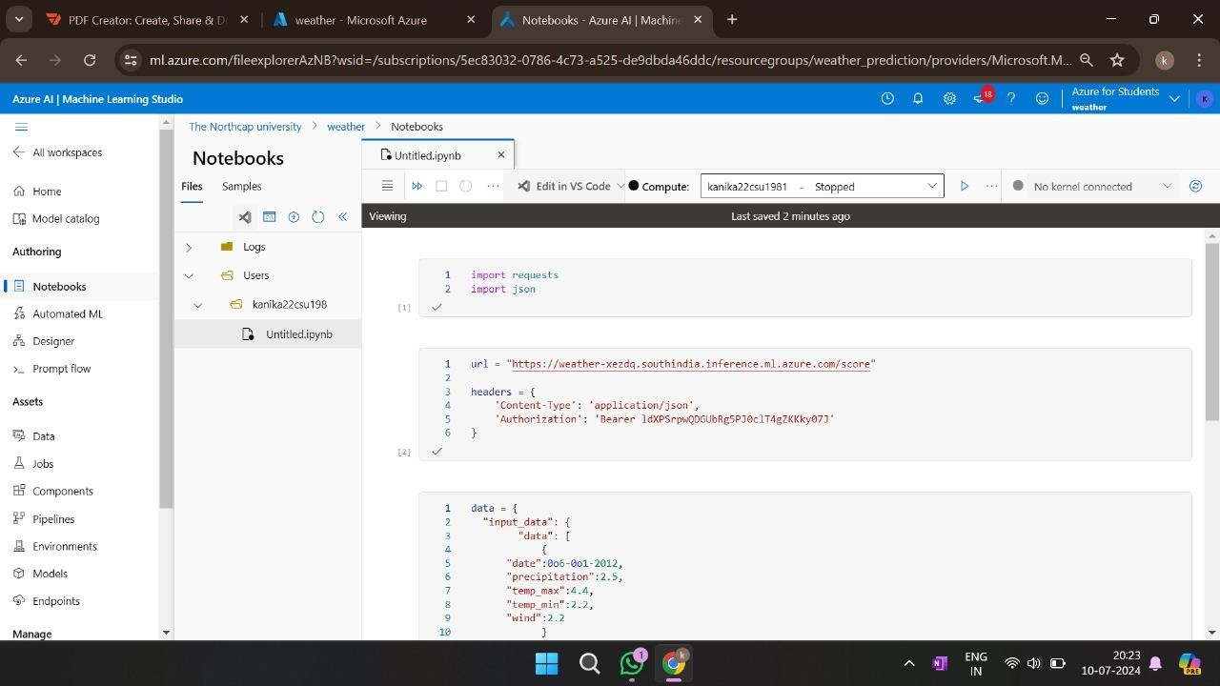
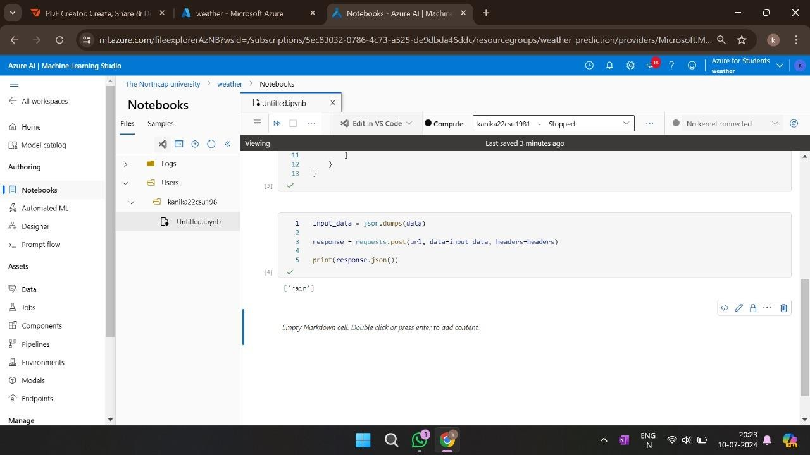
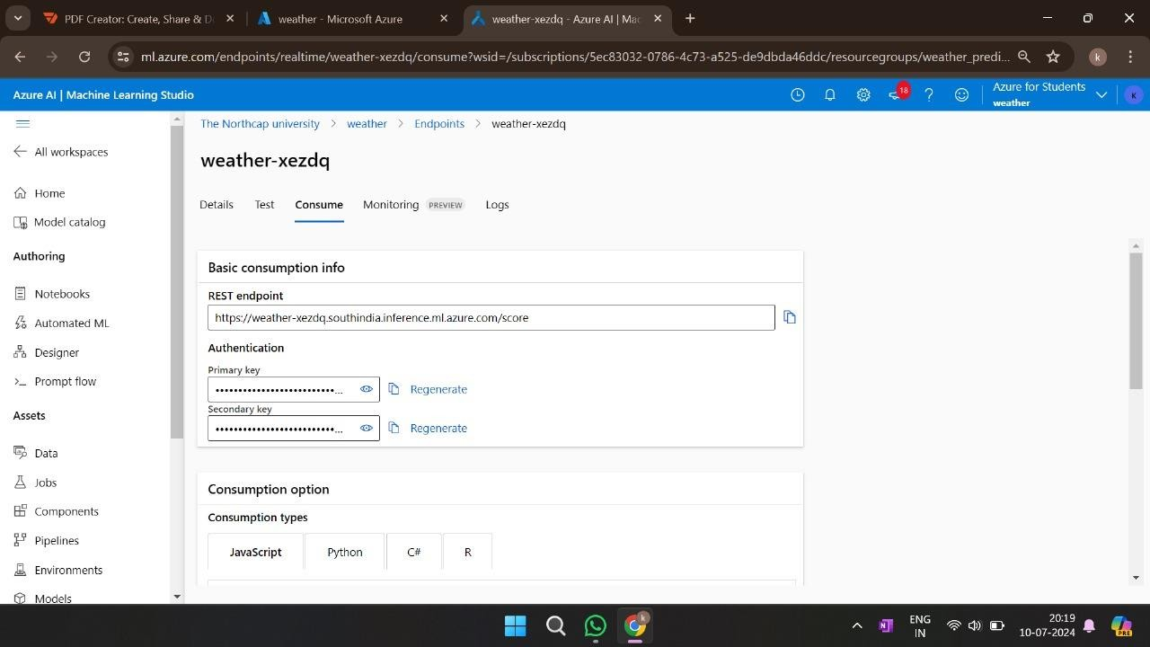

CONCLUSION
This project successfully demonstrated how Azure AI can be leveraged for weather prediction. The model provides reliable forecasts, contributing to sectors like agriculture, public safety, and environmental management. Future improvements could include incorporating real-time sensor data and advanced deep learning models.

FUTURE ENHANCEMENTS
- Implementing deep learning models for improved accuracy.
- Integrating real-time weather APIs for live data updates.
- Expanding the dataset to include global weather conditions.

